**. Installed tomcat and kept and war into webapps location.**

<http://192.168.0.8:7080/rest-21x/>

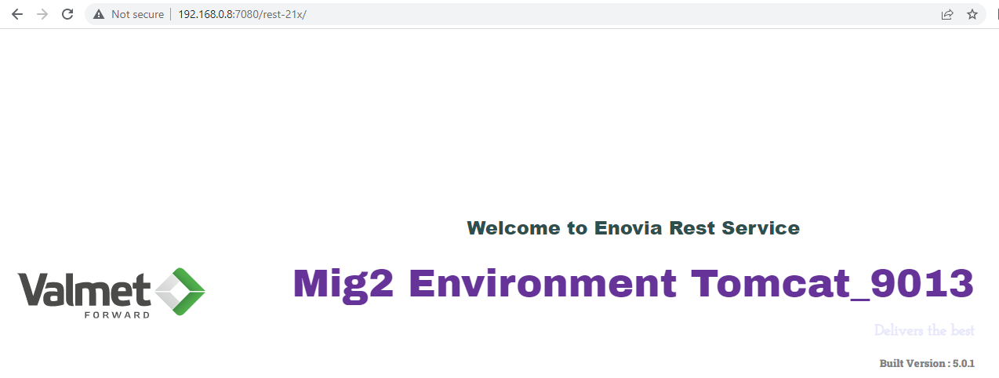

**. Target is to configure reverse proxy using http & https**

<http://restservicecheck.com:8180/rest-21x>

<https://restservicecheck.com:443/rest-21x>

**. Installed httpd**

**. Update httpd.conf**

Listen 8180

Listen 8280

Listen 443

Include /etc/httpd/vhost/restservicecheck.conf

Include /etc/httpd/vhost/restservicecheckhttps.conf

Include /etc/httpd/vhost/httpwithoutfragment.conf



**. Vhost creation for http & https**

**. Vhost for http**

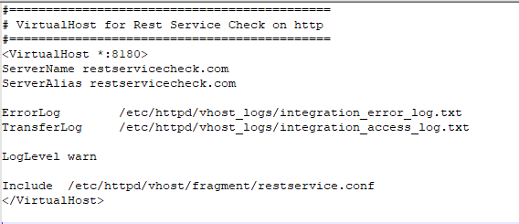



**. Need to create self signed certificates**

<https://www.baeldung.com/openssl-self-signed-cert>





**. Vhost for https**

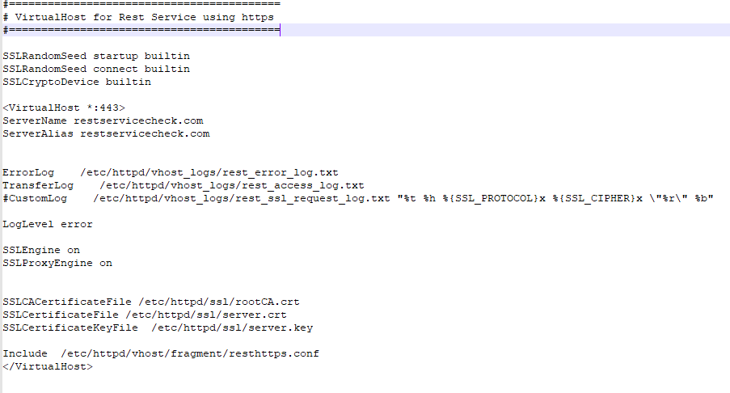



**. Fragment file creation for http**

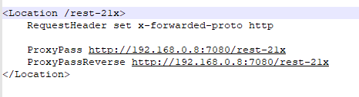



**. Fragment file creation for https**

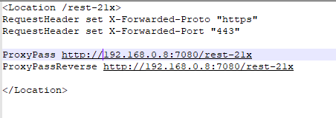



**. Vhost for http without fragment file**

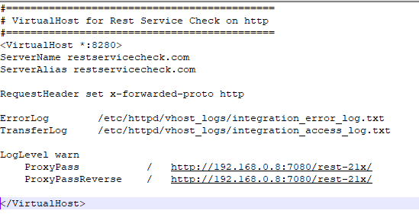



**. Need to check httpd syntax is okay or not. httpd -t**

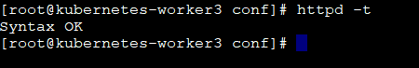

**. Restart httpd service**

**. Need to update hosts file as it is not real DNS**C:\Windows\System32\drivers\etc\hosts



**. Verification**

<http://restservicecheck.com:8180/rest-21x>

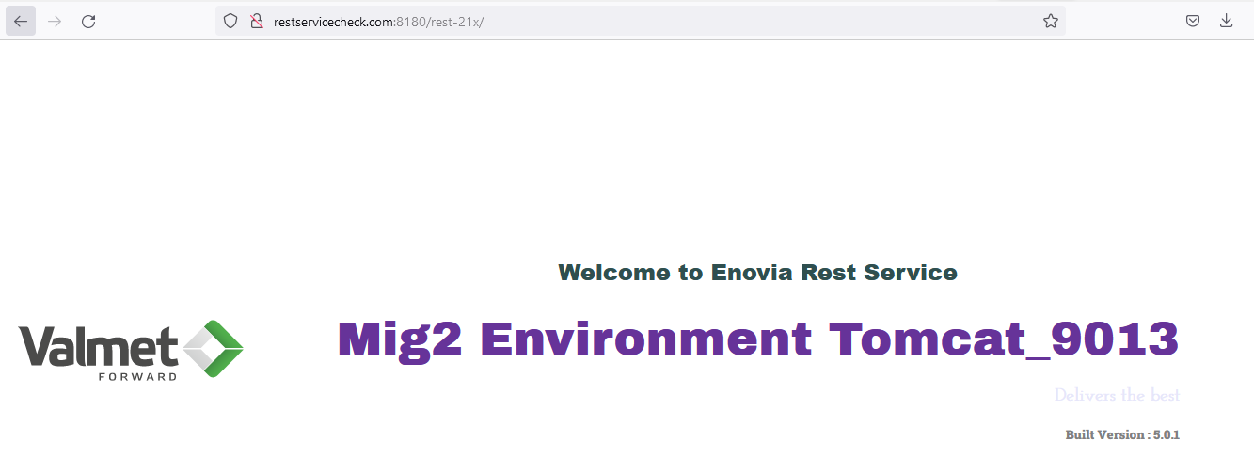

<https://restservicecheck.com:443/rest-21x>

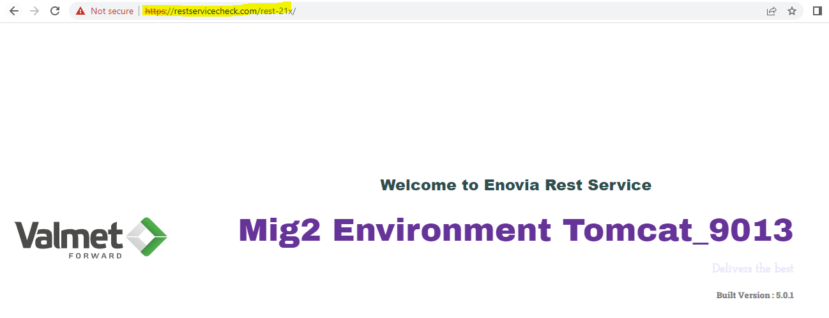

**Load Balancing Using Haproxy**

**. Need to create two tomcat service or two tomcat instance. Here we have created 2 tomcat service & kept same .war(rest-21x) file into webapps location.** <http://192.168.0.8:7080/rest-21x>

<http://192.168.0.8:7090/rest-21x>

**. Need to update vhost/fragment file**

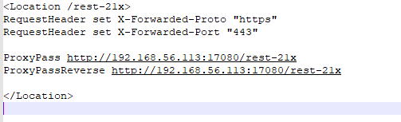



**. Need to install haproxy**

yum install haproxy

**. Haproxy installed location**

/etc/haproxy

**. Haproxy configuration**

/etc/haproxy/haproxy.cfg

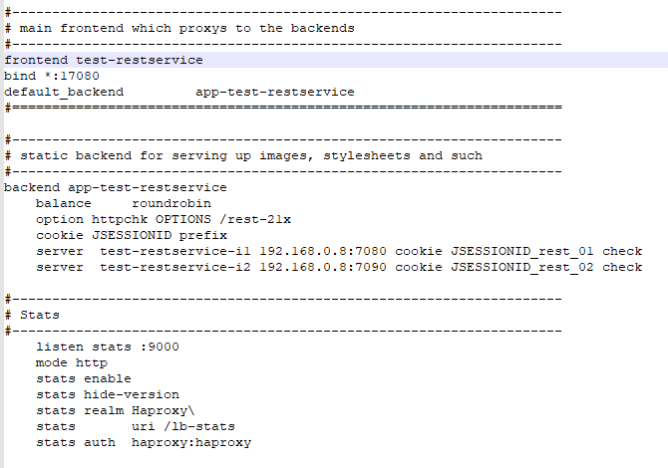



**. Haproxy syntax check**

haproxy -c -V -f /etc/haproxy/haproxy.cfg -c



**. Restart haproxy**

systemctl restart haproxy

**. Verification**

<https://restservicecheck.com:443/rest-21x>



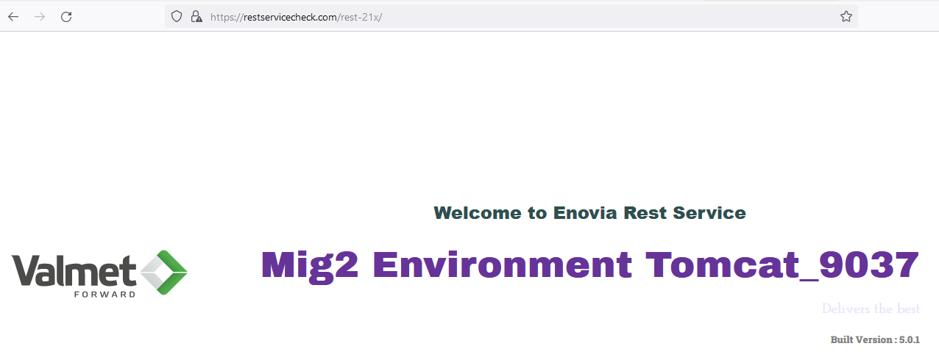

**. Load Balancing working perfectly.**

**. Haproxy Dashboard**

<http://192.168.56.113:9000/lb-stats>

